LINEAR PROGRAMMING REVISION – LEO’S LAUNDROMAT

The clothes dryers at Leo’s Laundromat can be either coin- or token-operated. Leo is considering how many clothes dryers should be coin-operated and how many should be token-operated.
Each coin-operated clothes dryer generates income of $1000 per month.
Each token-operated clothes dryer generates income of $800 per month.
He has space at his Laundromat for up to 40 clothes dryers. Coin- and token-operated clothes dryers take up the same amount of space.
The current demand for token-operated clothes dryers means that Leo must have at least twice as many token-operated clothes dryers than coin-operated clothes dryers.
He has an ongoing contract with the company that makes the tokens, and needs to have at least 10 token-operated clothes dryers at his Laundromat.
The diary that sells the tokens is not open 24 hours a day, so he needs to have at least 6 coin-operated clothes dryers at his Laundromat.

Leo’s income per month from the clothes dryers is given by the function:
Income = 1000c + 800t

Use the information to calculate how many coin-operated and token-operated clothes dryers Leo should install at his Laundromat to maximise his monthly income.

Step 1: Write inequations
This information may be useful (one equation per statement):
He has space at his Laundromat for up to 40 clothes dryers

Leo must have at least twice as many token-operated clothes dryers than coin-operated clothes dryers.

At least 10 token-operated

At least 6 coin-operated

Step 2: Draw Axis
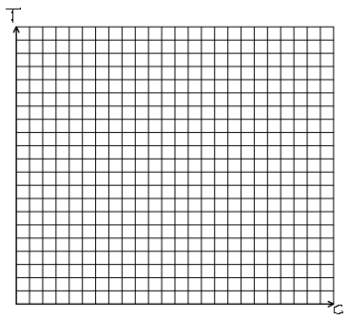
Step 3: Draw lines

Step 4: Shade out

Step 5: Find vertices of the feasible region
( , ) ( , ) ( , ) ( , )

Step 6: Find the maximum profit
This information may be useful:
Income = 1000c + 800t

Step 6: Write a statement answering the question.
Leo should buy …

